READ A NUMBER AND SQUARE

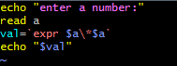

**OUTPUT**

